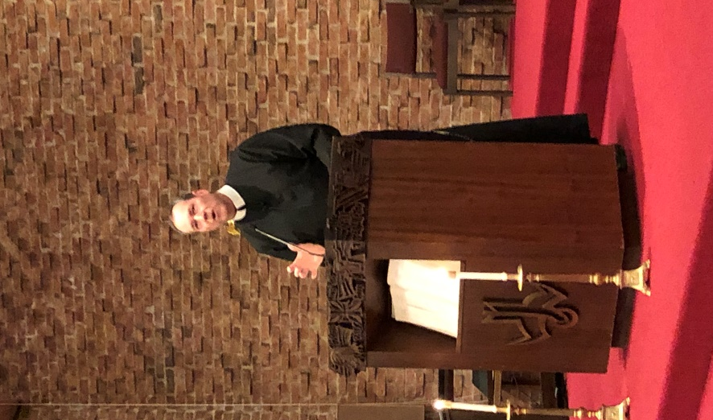

Fr. MacDonald is a Redemptorist priest from Woburn, Massachusetts, about 10 miles north of Boston. He entered the Redemptorist Missionary order after attending Boston College and playing seven years of professional baseball with the Pittsburgh Pirates organization and overseas in Holland and Australia. He is a member of the Boston College Hall of Fame. He was ordained to the priesthood in 1991 and has worked as a parish priest in Dominica, New York, Boston, St. Lucia, and the Virgin Islands. He is currently assigned to the Redemptorist Community in New Smyrna Beach, Florida.

